
./
Power Window Report

Course Code: <CODE>


Version Number:
Module: Model Based System Engineering

Ver. Rel. No. | Release Date | Prepared. By | Reviewed By | Approved By | Remarks/Revision Details
1 | 18/03/2021 | Arnav Kandpal (99003730)
Document History

Contents

1 -A brief introduction to power window………………………………………………………..1
2 -Power Window Switch configuration 3
3-internal circuitry of power windows…………………………………………………………………..
4-Ic used in power switches………………………………………………………………………………..

- A Brief Introduction to Power Windows:
Power windows have a structure much like the hand powered or manual windows. The difference is the handle bars are replaced with motor and the motion is now actuated with the actuator or power circuit thus the name “Power Window”.
Here is the motor and window setup on the door panel for Power window.
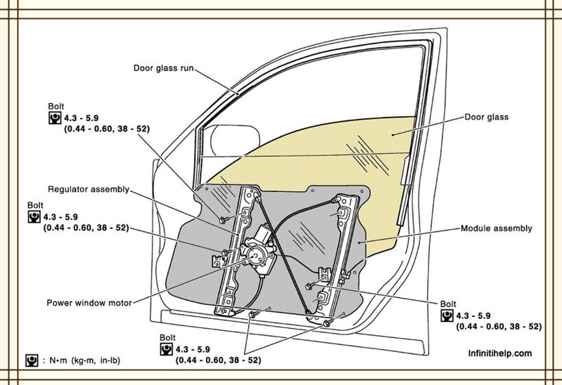
Power Window motor Configuration inside the car power window switch configuration is generally as follows:
- 5- Switches on driver side (4 Window Switch and 1 Disable Passenger Switch)
- 1 switch each on rest of the remaining doors
- Total of 7 Switches.

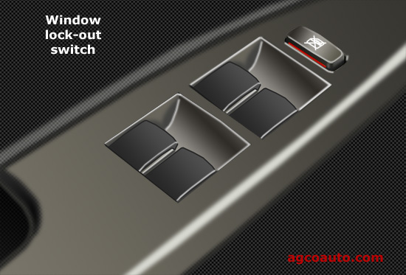

- Power Window Switch Interface:

- Power windows often employs “Rocker Switch” or “Toggle Switch”
- “Rocker” switches are designed to pivot on a center hinge, effectively operating like a “see-saw.”
- “Toggle” switches operate using small levers that push back and forth to open and close a window.
- Here is the internal circuitry for GMC Sierra for an instance of communication between driver switch, passenger switch, and the window pane to control.
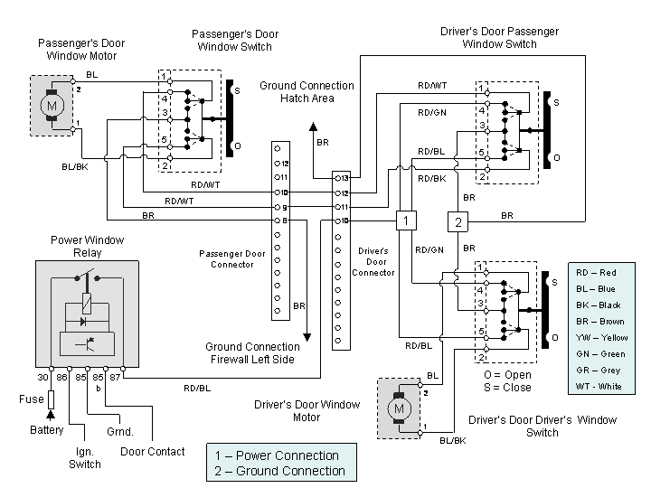

Driver Power Window Switch: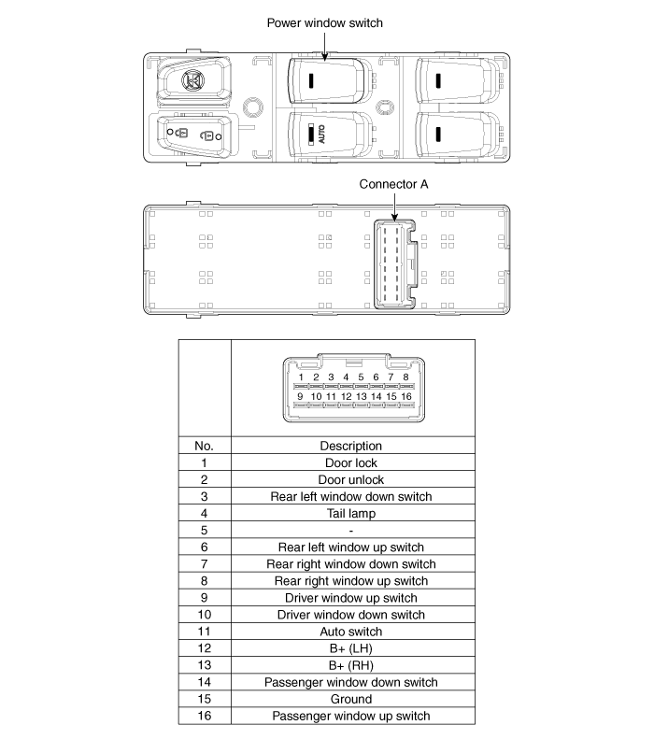

Passenger Power Window Switch
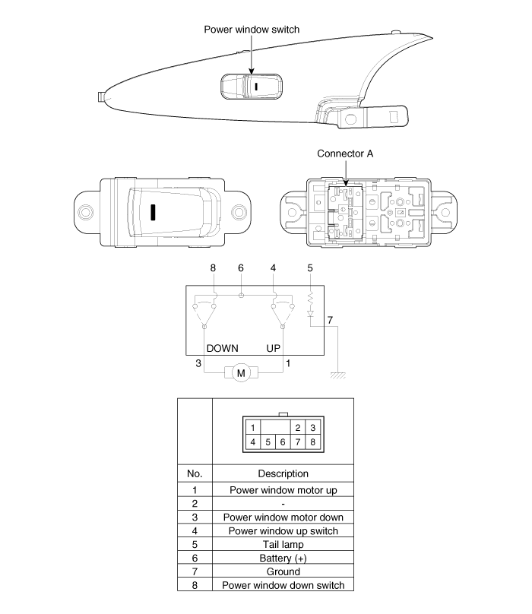
Rear Power Window Switch
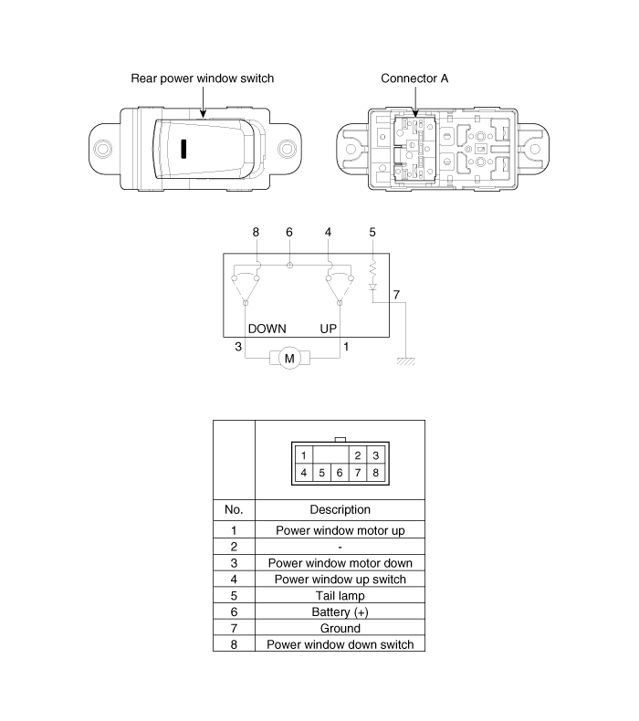

- IC used in power circuit switches:
Many different types of internal circuit can be used in the power window operation but we will be focusing on the KA3903 as it supports 2 different mode for same motor which would be useful for the anti-pinch operation.
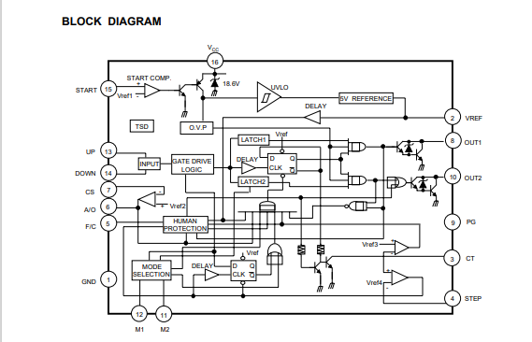
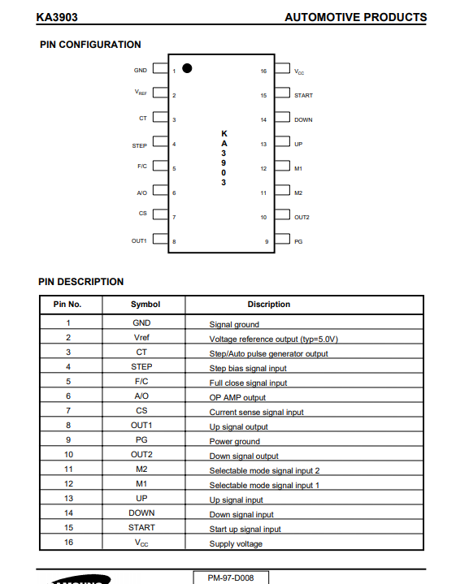
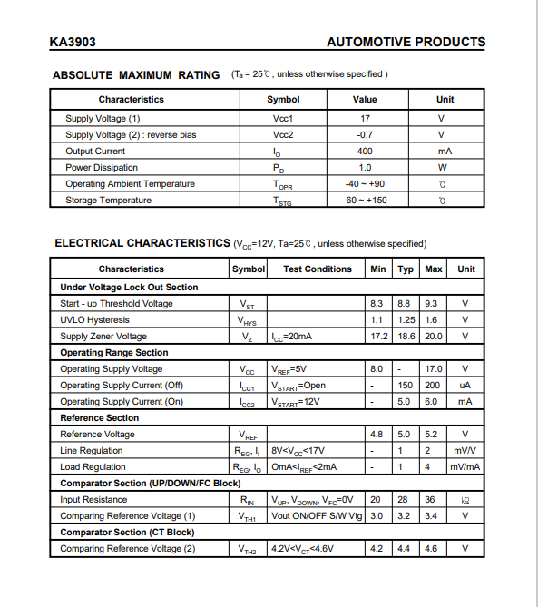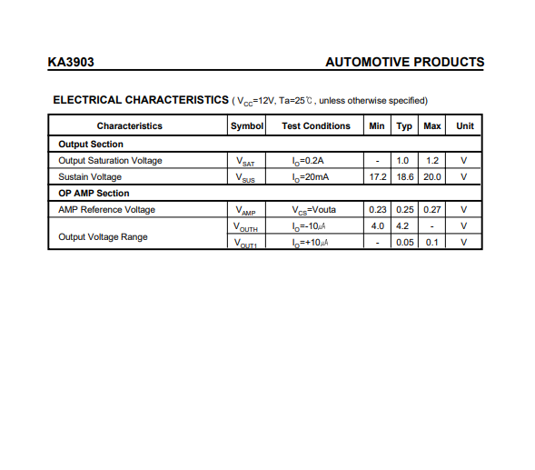

- Inputs
- Rocker Switches: “Rocker” switches are designed to pivot on a center hinge, effectively operating like a “see-saw.”
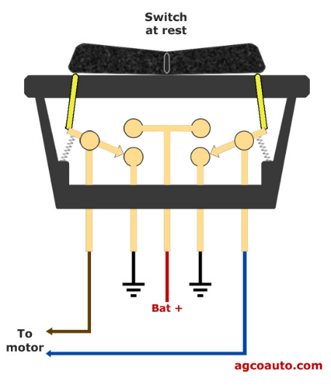

- Position Sensor:
- Reed sensors are generally used as the position sensor for power windows.
- Every time the magnet passes through the sensors it detects speed and direction.
We will be using Infeneon TLE5009 series Reed Sensors:
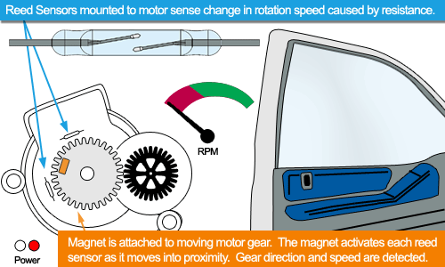
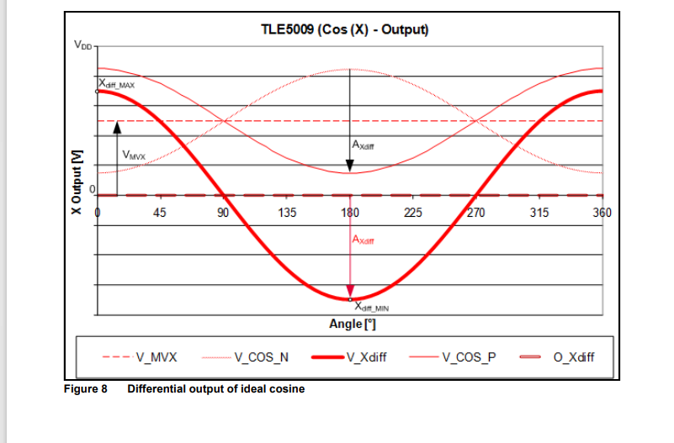

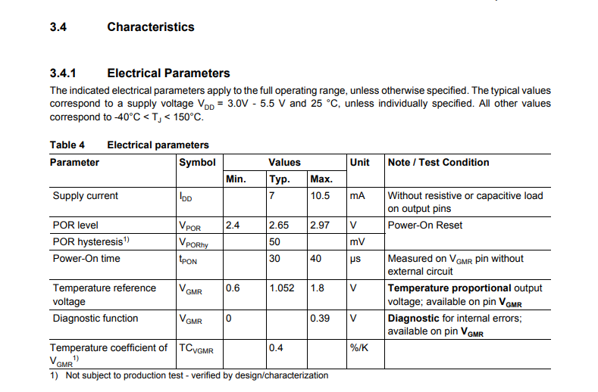

- Current Sensor:
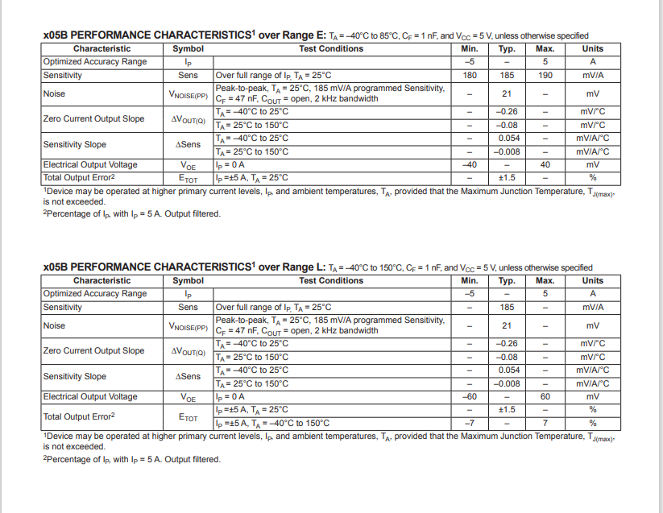
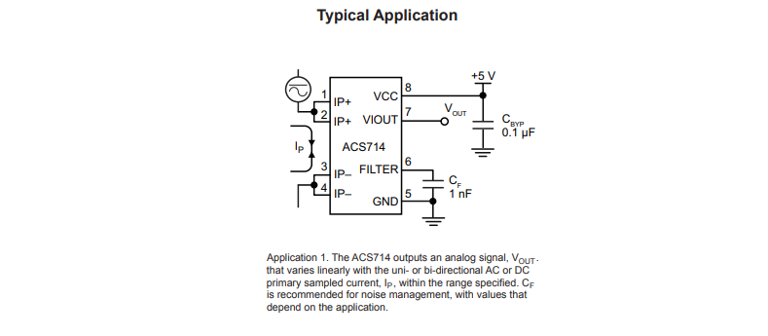
We are using ACS714ELCTR-05B-T, Automotive Grade, Fully Integrated, Hall Effect-Based Linear Current Sensor IC with 2.1 kVRMS Voltage Isolation and a Low-Resistance Current Conductor as our current sensor.
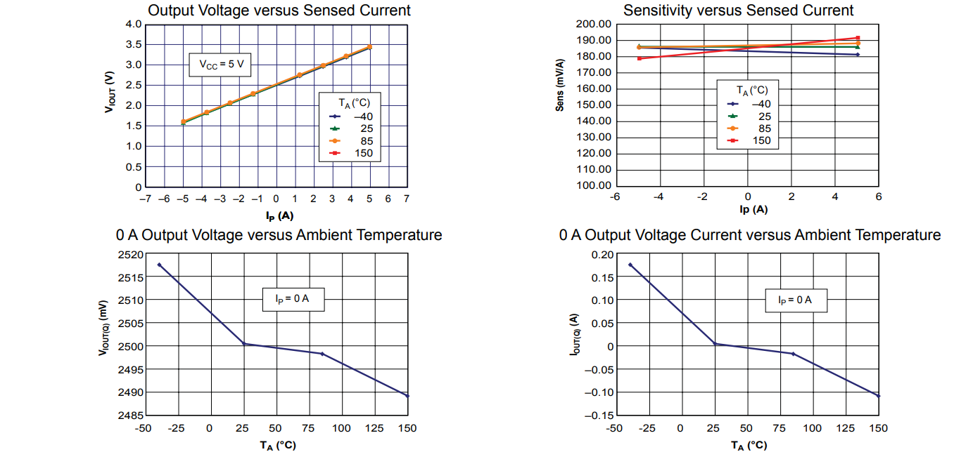
While other good option for current sensors are

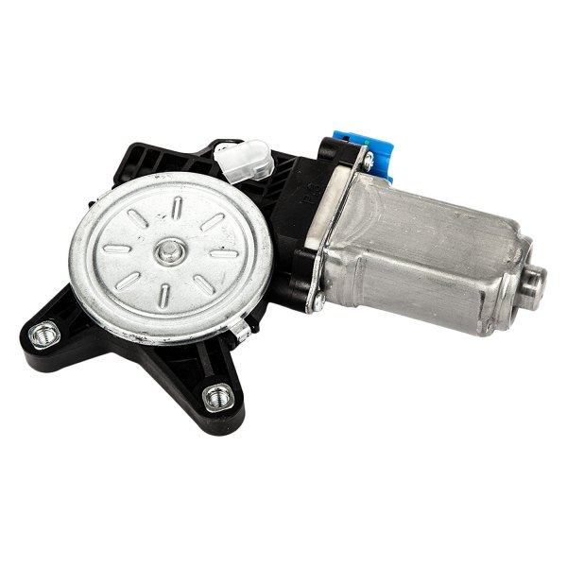
- Motor Specs:
The motor we have considered is ACDelco 95391354- GM motors original part

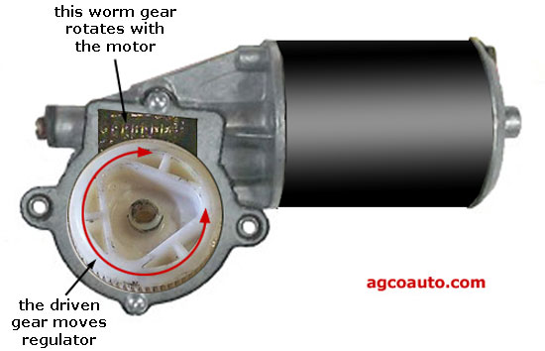
Here are the specs for a typical motor of a power window with a standard 12V input and variable current draw depending upon the load on the mirror.

The driven gear attaches to the regulator-drive gear, often using drive rollers. These rollers allow for any slight misalignment, smooth window travel and quite power window operation.
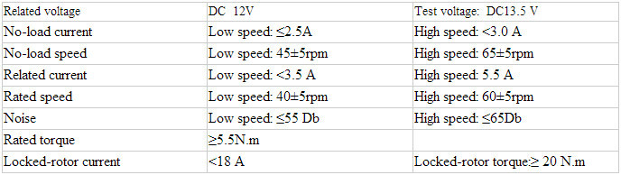

6) The Federal Motor Vehicle Safety Standards for Power Operated Window
The FMVSS No. 118 Standards states that
1. A position that is at least as open as the position at the time closing was initiated;
2. A position that is not less than 125 millimeters more open than the position at the time the window reversed direction; or
3. A position that permits a semi-rigid cylindrical rod that is 200 mm in diameter to be placed through the opening at the same location as the test rod.
4 S5.3 - If a vehicle uses proximity detection by infrared reflection to stop and reverse a power-operated window, partition, or roof panel, the infrared source shall project infrared light at a wavelength of not less than 850 nm and not more than 1050 nm. The system shall meet the requirements in

7)Anti-Pinch Feature:

Algorithm:
- Equation:
The below equation is for the armature current that is detected by the current sensor and the pinch decision is based on that.
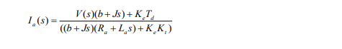

- Block Diagram: 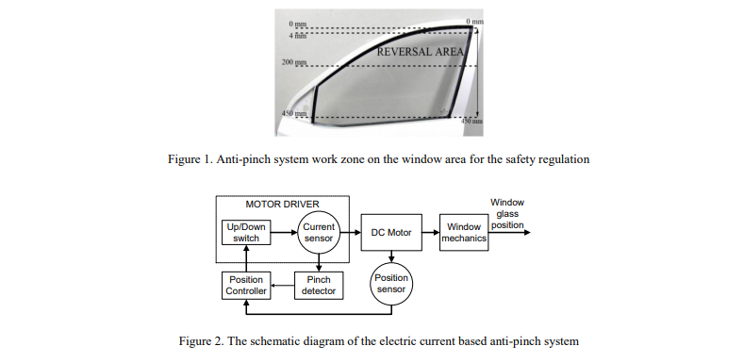

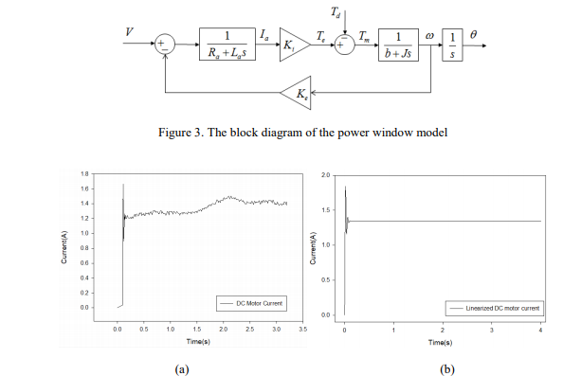
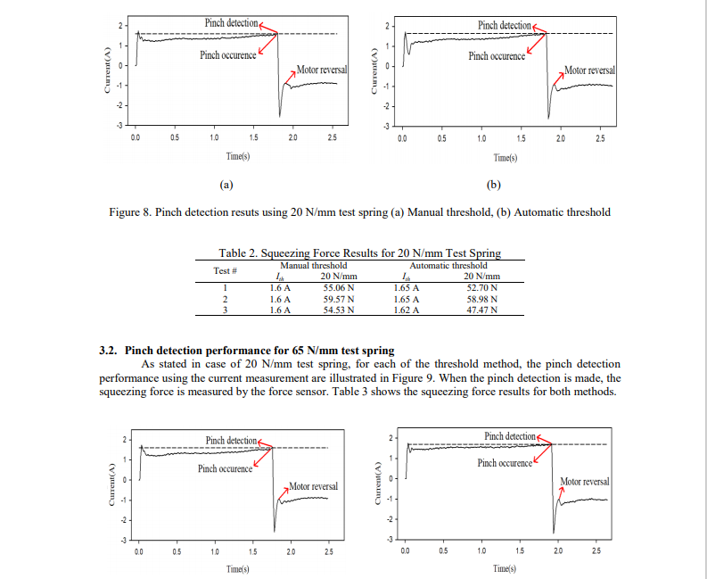

The current threshold (Ith) can be calculated from Equation (1) at transient time using the current value at transient time (Itr) by th tr I = 0.97× I (3) where a reasonable automatic threshold level to detect the pinch condition is 97% of the maximum current of the transient time. This method can be acknowledged as a systematic way to solve the pinch detection rather than the manual threshold.

